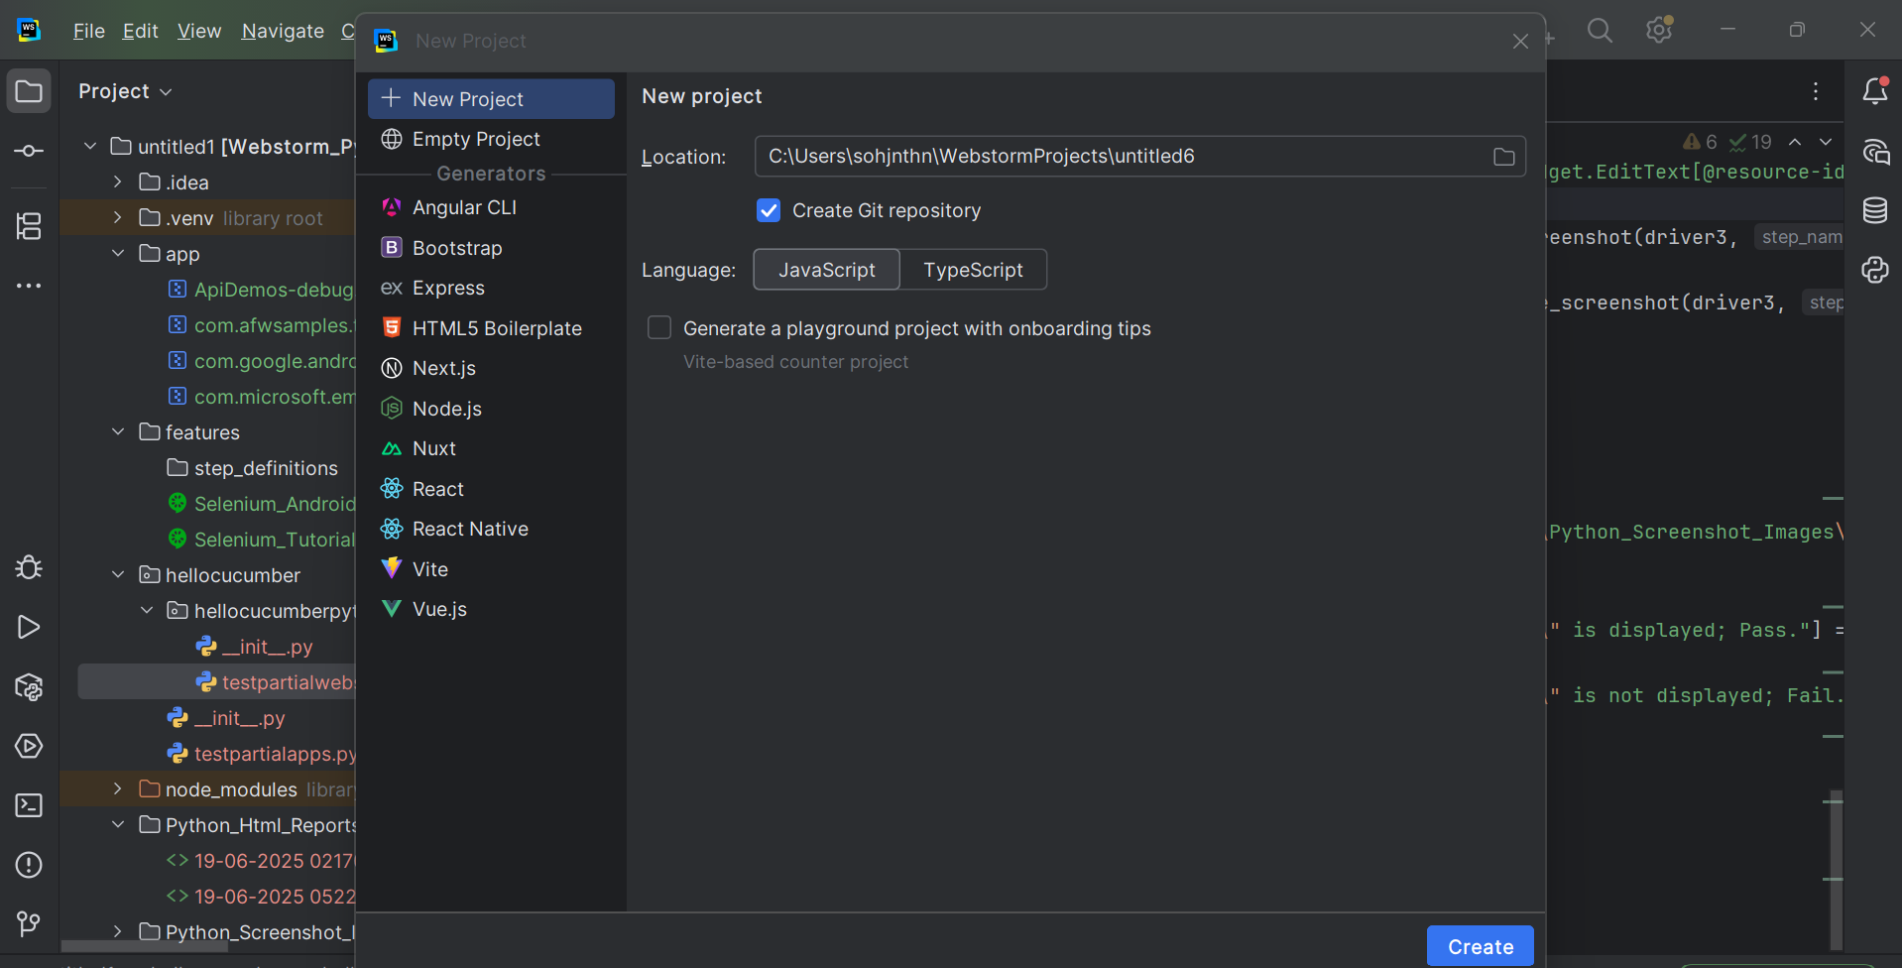

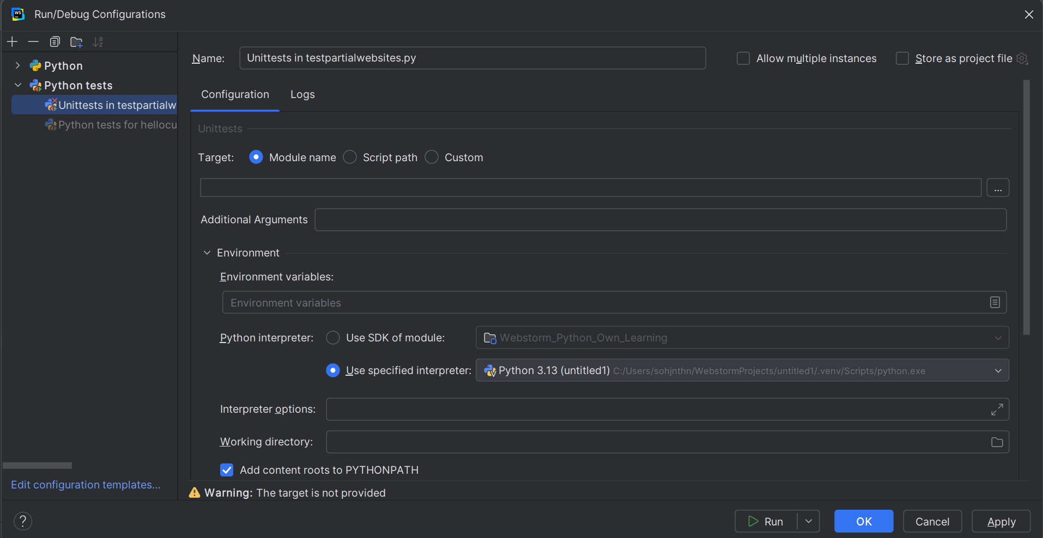

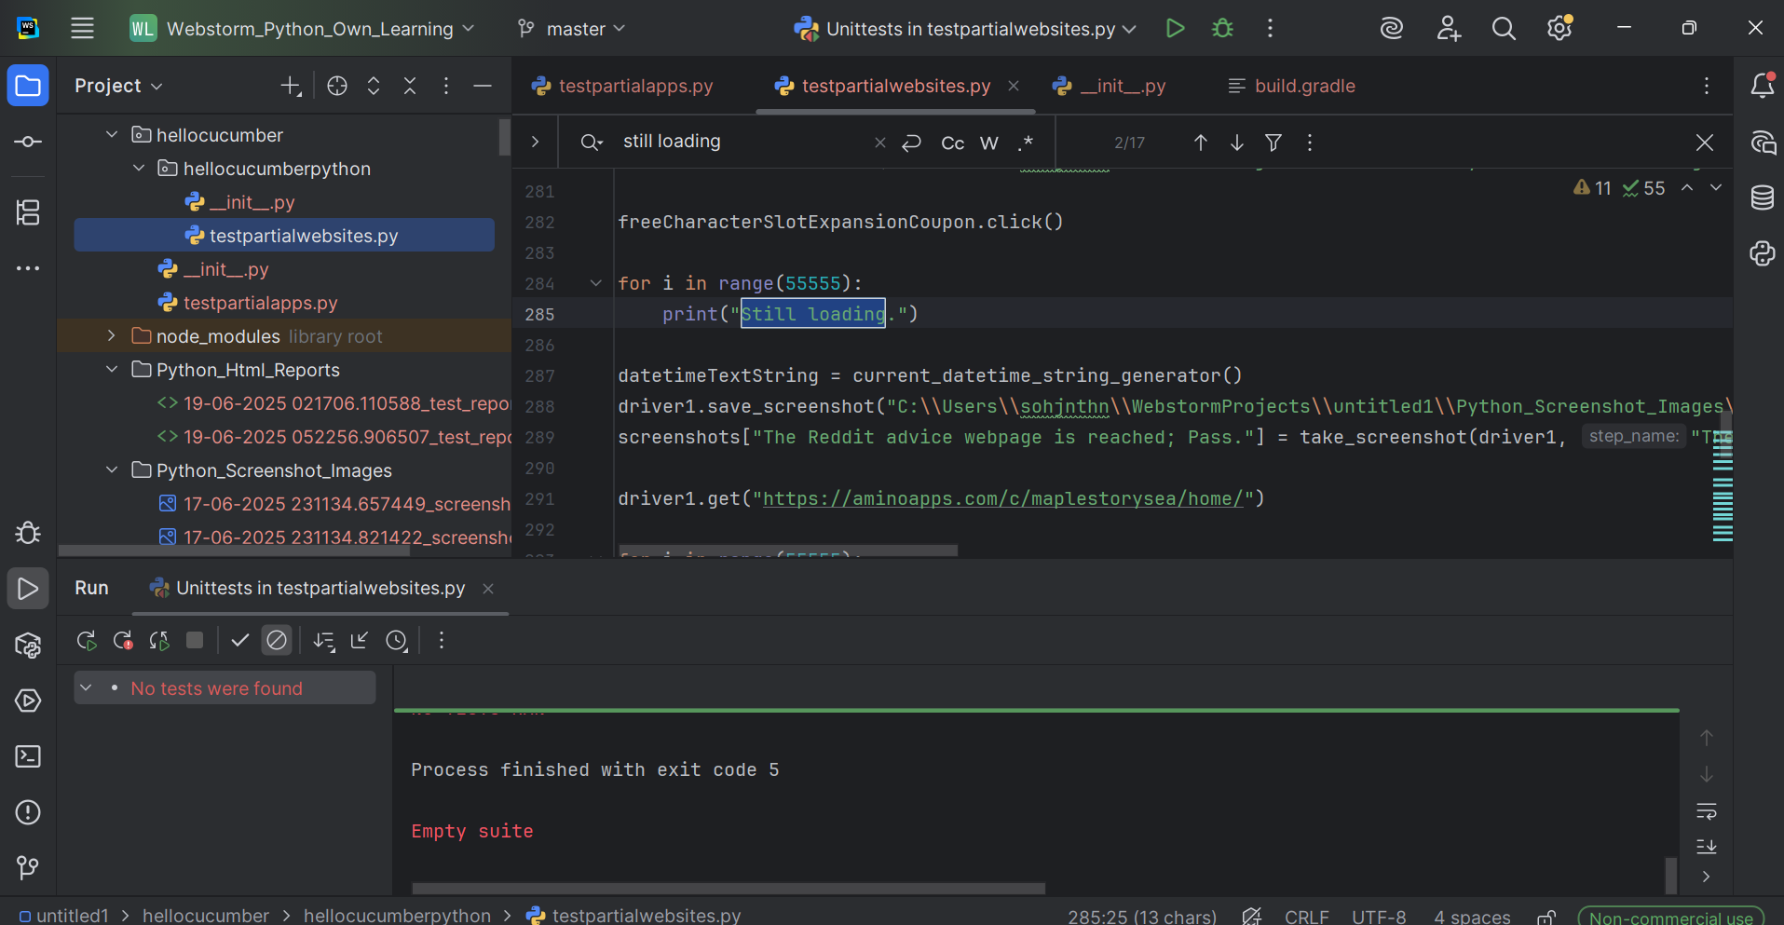

testpartialwebsites.py
from selenium import webdriver
from selenium.webdriver.common.by import By

from datetime import datetime

from selenium.webdriver.common.utils import Keys

import os

def current_datetime_string_generator():
datetimee = datetime.now()
print("datetime is: " + datetimee.__str__())
datetimeeText = datetimee.strftime("%d-%m-%Y %H%M%S.%f")
datetimeeTextString = datetimeeText.__str__()
print("datetimeText is: " + datetimeeTextString)
return datetimeeTextString

def take_screenshot(driver, step_name):
datetimeeeText = datetime.now().strftime("%d-%m-%Y %H%M%S.%f")
datetimeeeTextString = datetimeeeText.__str__()
screenshot_path = os.path.join("C:\\Users\\sohjnthn\\WebstormProjects\\untitled1\\Python_Screenshot_Images\\" + datetimeeeTextString + "_screenshot.png")
driver.save_screenshot(screenshot_path)
return screenshot_path

def generate_html_report(screenshots):
report_path = "C:\\Users\\sohjnthn\\WebstormProjects\\untitled1\\Python_Html_Reports\\" + current_datetime_string_generator() + "_test_report.html"
with open(report_path, "w") as report:
report.write("<html><head><title>Test Report</title></head><body>")
report.write("<h1>Test Report with Screenshots</h1>")
for step, screenshot in screenshots.items():
report.write(f"<h2>{step}</h2>")
report.write(f'<img src="{screenshot}" alt="{step}" style="width:600px;"><br>')
report.write("</body></html>")
print(f"Report generated: {report_path}")

screenshots = {}

driver1 = webdriver.Chrome()

driver1.get("https://demo.guru99.com/")

datetimeTextString = current_datetime_string_generator()
driver1.save_screenshot("C:\\Users\\sohjnthn\\WebstormProjects\\untitled1\\Python_Screenshot_Images\\" + datetimeTextString + "_" + "screenshot.png")

emailInputField = driver1.find_element(By.NAME, "emailid")

datetimeTextString = current_datetime_string_generator()
driver1.save_screenshot("C:\\Users\\sohjnthn\\WebstormProjects\\untitled1\\Python_Screenshot_Images\\" + datetimeTextString + "_" + "screenshot.png")
if emailInputField.is_displayed():
screenshots["The Email Input Field is displayed; Pass."] = take_screenshot(driver1, "The Email Input Field is displayed; Pass.")
else:
screenshots["The Email Input Field is not displayed; Fail."] = take_screenshot(driver1, "The Email Input Field is not displayed; Fail.")

emailInputField.send_keys("abc@gmail.com")

datetimeTextString = current_datetime_string_generator()
driver1.save_screenshot("C:\\Users\\sohjnthn\\WebstormProjects\\untitled1\\Python_Screenshot_Images\\" + datetimeTextString + "_" + "screenshot.png")
if emailInputField.is_displayed():
screenshots["The Email Input Field's text \"abc@gmail.com\" is displayed; Pass."] = take_screenshot(driver1, "The Email Input Field's text \"abc@gmail.com\" is displayed; Pass.")
else:
screenshots["The Email Input Field's text \"abc@gmail.com\" is not displayed; Fail."] = take_screenshot(driver1, "The Email Input Field's text \"abc@gmail.com\" is not displayed; Fail.")

submitButton = driver1.find_element(By.NAME, "btnLogin")

datetimeTextString = current_datetime_string_generator()
driver1.save_screenshot("C:\\Users\\sohjnthn\\WebstormProjects\\untitled1\\Python_Screenshot_Images\\" + datetimeTextString + "_" + "screenshot.png")
if submitButton.is_displayed():
screenshots["The Submit Button is displayed; Pass."] = take_screenshot(driver1, "The Submit Button is displayed; Pass.")
else:
screenshots["The Submit Button is not displayed; Fail."] = take_screenshot(driver1, "The Submit Button is not displayed; Fail.")

submitButton.click()

datetimeTextString = current_datetime_string_generator()
driver1.save_screenshot("C:\\Users\\sohjnthn\\WebstormProjects\\untitled1\\Python_Screenshot_Images\\" + datetimeTextString + "_" + "screenshot.png")
screenshots["The resulting webpage has been reached; Pass."] = take_screenshot(driver1, "The resulting webpage has been reached; Pass.")

driver1.get("https://www.bing.com")

datetimeTextString = current_datetime_string_generator()
driver1.save_screenshot("C:\\Users\\sohjnthn\\WebstormProjects\\untitled1\\Python_Screenshot_Images\\" + datetimeTextString + "_" + "screenshot.png")
if driver1.title.__eq__("Search - Microsoft Bing"):
screenshots["The Microsoft Bing webpage has been reached; Pass."] = take_screenshot(driver1, "The Microsoft Bing webpage has been reached; Pass.")
else:
screenshots["The Microsoft Bing webpage has not been reached; Fail."] = take_screenshot(driver1, "The Microsoft Bing webpage has been reached; Fail.")

microsoftBingSearchBar = driver1.find_element(By.NAME, "q")

datetimeTextString = current_datetime_string_generator()
driver1.save_screenshot("C:\\Users\\sohjnthn\\WebstormProjects\\untitled1\\Python_Screenshot_Images\\" + datetimeTextString + "_" + "screenshot.png")

if microsoftBingSearchBar.is_displayed():
screenshots["The Microsoft Bing search bar is displayed; Pass."] = take_screenshot(driver1, "The Microsoft Bing search bar is displayed; Pass.")
else:
screenshots["The Microsoft Bing search bar is not displayed; Fail."] = take_screenshot(driver1, "The Microsoft Bing search bar is not displayed; Fail.")

microsoftBingSearchBar.send_keys("MapleStorySEA Unfunded Amino")

datetimeTextString = current_datetime_string_generator()
driver1.save_screenshot("C:\\Users\\sohjnthn\\WebstormProjects\\untitled1\\Python_Screenshot_Images\\" + datetimeTextString + "_" + "screenshot.png")
screenshots["The Microsoft Bing search bar's search term \"MapleStorySEA Unfunded Amino\" has been entered; Pass."] = take_screenshot(driver1, "The Microsoft Bing search bar's search term \"MapleStorySEA Unfunded Amino\" has been entered; Pass.")

microsoftBingSearchBarMagnifyingGlassButton = driver1.find_element(By.ID, "search_icon")

if microsoftBingSearchBarMagnifyingGlassButton.is_displayed():
screenshots["The Microsoft Bing search bar's magnifying glass button is displayed; Pass."] = take_screenshot(driver1, "The Microsoft Bing search bar's magnifying glass button is displayed; Pass.")
else:
screenshots["The Microsoft Bing search bar's magnifying glass button is not displayed; Fail."] = take_screenshot(driver1, "The Microsoft Bing search bar's magnifying glass button is not displayed; Fail.")

datetimeTextString = current_datetime_string_generator()
driver1.save_screenshot("C:\\Users\\sohjnthn\\WebstormProjects\\untitled1\\Python_Screenshot_Images\\" + datetimeTextString + "_" + "screenshot.png")

microsoftBingSearchBarMagnifyingGlassButton.click()

datetimeTextString = current_datetime_string_generator()
driver1.save_screenshot("C:\\Users\\sohjnthn\\WebstormProjects\\untitled1\\Python_Screenshot_Images\\" + datetimeTextString + "_" + "screenshot.png")
screenshots["The Search Results webpage has been reached; Pass."] = take_screenshot(driver1, "The Search Results webpage has been reached; Pass.")

# driver1.get("https://www.bing.com/search?q=MapleStorySEA+Unfunded+Amino")

datetimeTextString = current_datetime_string_generator()
driver1.save_screenshot("C:\\Users\\sohjnthn\\WebstormProjects\\untitled1\\Python_Screenshot_Images\\" + datetimeTextString + "_" + "screenshot.png")

searchTab = driver1.find_element(By.ID, "b-scopeListItem-copilotsearch")

if searchTab.is_displayed():
screenshots["The Search tab is displayed; Pass."] = take_screenshot(driver1, "The Search tab is displayed; Pass.")
else:
screenshots["The Search tab is not displayed; Fail."] = take_screenshot(driver1, "The Search tab is not displayed; Fail.")

datetimeTextString = current_datetime_string_generator()
driver1.save_screenshot("C:\\Users\\sohjnthn\\WebstormProjects\\untitled1\\Python_Screenshot_Images\\" + datetimeTextString + "_" + "screenshot.png")

searchTab.click()

datetimeTextString = current_datetime_string_generator()
driver1.save_screenshot("C:\\Users\\sohjnthn\\WebstormProjects\\untitled1\\Python_Screenshot_Images\\" + datetimeTextString + "_" + "screenshot.png")

allTab = driver1.find_element(By.ID, "b-scopeListItem-web")

datetimeTextString = current_datetime_string_generator()
driver1.save_screenshot("C:\\Users\\sohjnthn\\WebstormProjects\\untitled1\\Python_Screenshot_Images\\" + datetimeTextString + "_" + "screenshot.png")

if allTab.is_displayed():
screenshots["The All tab is displayed; Pass."] = take_screenshot(driver1, "The All tab is displayed; Pass.")
else:
screenshots["The All tab is not displayed; Fail."] = take_screenshot(driver1, "The All tab is not displayed; Fail.")

allTab.click()

datetimeTextString = current_datetime_string_generator()
driver1.save_screenshot("C:\\Users\\sohjnthn\\WebstormProjects\\untitled1\\Python_Screenshot_Images\\" + datetimeTextString + "_" + "screenshot.png")
if driver1.title.__eq__("MapleStorySEA Unfunded Amino - Search"):
screenshots["The Search Results webpage is reached; Pass."] = take_screenshot(driver1, "The Search Results webpage is reached; Pass.")
else:
screenshots["The Search Results webpage is not reached; Fail."] = take_screenshot(driver1, "The Search Results webpage is not reached; Fail.")

requiredSearchResultLink = driver1.find_element(By.PARTIAL_LINK_TEXT, "Featured | [MapleStorySEA] Unfunded Tips")

datetimeTextString = current_datetime_string_generator()
driver1.save_screenshot("C:\\Users\\sohjnthn\\WebstormProjects\\untitled1\\Python_Screenshot_Images\\" + datetimeTextString + "_" + "screenshot.png")

for i in range(50):
requiredSearchResultLink.send_keys(Keys.ARROW_DOWN)

datetimeTextString = current_datetime_string_generator()
driver1.save_screenshot("C:\\Users\\sohjnthn\\WebstormProjects\\untitled1\\Python_Screenshot_Images\\" + datetimeTextString + "_" + "screenshot.png")
screenshots["The bottom of the Search Results webpage is reached; Pass."] = take_screenshot(driver1, "The bottom of the Search Results webpage is reached; Pass.")

for i in range(50):
requiredSearchResultLink.send_keys(Keys.ARROW_UP
)
datetimeTextString = current_datetime_string_generator()
driver1.save_screenshot("C:\\Users\\sohjnthn\\WebstormProjects\\untitled1\\Python_Screenshot_Images\\" + datetimeTextString + "_" + "screenshot.png")
screenshots["The top of the Search Results webpage is reached, and the required search result's partialLinkText would now be clicked on; Pass."] = take_screenshot(driver1, "The top of the Search Results webpage is reached, and the required search result's partialLinkText would now be clicked on; Pass.")

requiredSearchResultLink.click()

for i in range(55555):
print("Waiting for the loading to be completed.")

datetimeTextString = current_datetime_string_generator()
driver1.save_screenshot("C:\\Users\\sohjnthn\\WebstormProjects\\untitled1\\Python_Screenshot_Images\\" + datetimeTextString + "_" + "screenshot.png")
screenshots["The Amino webpage has been reached; Pass."] = take_screenshot(driver1, "The Amino webpage has been reached; Pass.")

driver1.get("https://aminoapps.com/c/maplestorysea/home/")

datetimeTextString = current_datetime_string_generator()
driver1.save_screenshot("C:\\Users\\sohjnthn\\WebstormProjects\\untitled1\\Python_Screenshot_Images\\" + datetimeTextString + "_" + "screenshot.png")
screenshots["The Amino webpage has been reached; Pass."] = take_screenshot(driver1, "The Amino webpage has been reached; Pass.")

aminoSearchBar = driver1.find_element(By.CLASS_NAME, "nav-search-input")

datetimeTextString = current_datetime_string_generator()
driver1.save_screenshot("C:\\Users\\sohjnthn\\WebstormProjects\\untitled1\\Python_Screenshot_Images\\" + datetimeTextString + "_" + "screenshot.png")
if(aminoSearchBar.is_displayed()):
screenshots["The Amino search bar is displayed; Pass."] = take_screenshot(driver1, "The Amino search bar is displayed; Pass.")
else:
screenshots["The Amino search bar is not displayed; Fail."] = take_screenshot(driver1, "The Amino search bar is not displayed; Fail.")

aminoSearchBar.send_keys("MapleStorySEA Unfunded Amino")

datetimeTextString = current_datetime_string_generator()
driver1.save_screenshot("C:\\Users\\sohjnthn\\WebstormProjects\\untitled1\\Python_Screenshot_Images\\" + datetimeTextString + "_" + "screenshot.png")
if(aminoSearchBar.is_displayed()):
screenshots["The Amino search bar is displayed; Pass."] = take_screenshot(driver1, "The Amino search bar is displayed; Pass.")
else:
screenshots["The Amino search bar is not displayed; Fail."] = take_screenshot(driver1, "The Amino search bar is not displayed; Fail.")

maplestoryseaUnfundedAminoString = "MapleStorySEA Unfunded Amino"
maplestoryseaUnfundedAminoStringLength = maplestoryseaUnfundedAminoString.__len__()
for i in range(maplestoryseaUnfundedAminoStringLength):
aminoSearchBar.send_keys(Keys.BACK_SPACE)

datetimeTextString = current_datetime_string_generator()
driver1.save_screenshot("C:\\Users\\sohjnthn\\WebstormProjects\\untitled1\\Python_Screenshot_Images\\" + datetimeTextString + "_" + "screenshot.png")
if(aminoSearchBar.is_displayed()):
screenshots["The Amino search bar is displayed; Pass."] = take_screenshot(driver1, "The Amino search bar is displayed; Pass.")
else:
screenshots["The Amino search bar is not displayed; Fail."] = take_screenshot(driver1, "The Amino search bar is not displayed; Fail.")

aminoSearchBar.send_keys("MapleStorySEA Unfunded Amino")
datetimeTextString = current_datetime_string_generator()
driver1.save_screenshot("C:\\Users\\sohjnthn\\WebstormProjects\\untitled1\\Python_Screenshot_Images\\" + datetimeTextString + "_" + "screenshot.png")
if(aminoSearchBar.is_displayed()):
screenshots["The Amino search bar is displayed; Pass."] = take_screenshot(driver1, "The Amino search bar is displayed; Pass.")
else:
screenshots["The Amino search bar is not displayed; Fail."] = take_screenshot(driver1, "The Amino search bar is not displayed; Fail.")

threeWebElementsList = driver1.find_elements(By.TAG_NAME, "svg")
aminoSearchBarMagnifyingGlassButton = threeWebElementsList[0]
aminoSearchBar.send_keys("MapleStorySEA Unfunded Amino")
datetimeTextString = current_datetime_string_generator()
driver1.save_screenshot("C:\\Users\\sohjnthn\\WebstormProjects\\untitled1\\Python_Screenshot_Images\\" + datetimeTextString + "_" + "screenshot.png")
if(aminoSearchBarMagnifyingGlassButton.is_displayed()):
screenshots["The Amino search bar's magnifying glass button is displayed; Pass."] = take_screenshot(driver1, "The Amino search bar's magnifying glass button is displayed; Pass.")
else:
screenshots["The Amino search bar's magnifying glass button is not displayed; Fail."] = take_screenshot(driver1, "The Amino search bar's magnifying glass button is not displayed; Fail.")

aminoSearchBarMagnifyingGlassButton.click()

tagNameH3WebElementList = driver1.find_elements(By.TAG_NAME, "h3")
popularPostsText = tagNameH3WebElementList[0]
popularPostsTextString = popularPostsText.text
datetimeTextString = current_datetime_string_generator()
driver1.save_screenshot("C:\\Users\\sohjnthn\\WebstormProjects\\untitled1\\Python_Screenshot_Images\\" + datetimeTextString + "_" + "screenshot.png")
if popularPostsTextString.__eq__("Popular posts"):
screenshots["The Popular Posts' section's Popular Posts title is displayed; Pass."] = take_screenshot(driver1, "The Popular Posts' section's Popular Posts title is displayed; Pass.")
else:
screenshots["The Popular Posts' section's Popular Posts title is not displayed; Fail."] = take_screenshot(driver1, "TThe Popular Posts' section's Popular Posts title is not displayed; Fail.")

driver1.get("https://aminoapps.com/c/maplestorysea/home/")

datetimeTextString = current_datetime_string_generator()
driver1.save_screenshot("C:\\Users\\sohjnthn\\WebstormProjects\\untitled1\\Python_Screenshot_Images\\" + datetimeTextString + "_" + "screenshot.png")

privacyNoticeAcceptButton = driver1.find_element(By.CLASS_NAME, "confirm-close")

datetimeTextString = current_datetime_string_generator()
driver1.save_screenshot("C:\\Users\\sohjnthn\\WebstormProjects\\untitled1\\Python_Screenshot_Images\\" + datetimeTextString + "_" + "screenshot.png")
if privacyNoticeAcceptButton.is_displayed():
screenshots["The Privacy Notice Accept Button is displayed; Pass."] = take_screenshot(driver1, "The Privacy Notice Accept Button is displayed; Pass.")
else:
screenshots["The Privacy Notice Accept Button is not displayed; Fail."] = take_screenshot(driver1, "The Privacy Notice Accept Button is not displayed; Fail.")

privacyNoticeAcceptButton.click()

datetimeTextString = current_datetime_string_generator()
driver1.save_screenshot("C:\\Users\\sohjnthn\\WebstormProjects\\untitled1\\Python_Screenshot_Images\\" + datetimeTextString + "_" + "screenshot.png")
screenshots["The Privacy Notice pop-up has been closed; Pass."] = take_screenshot(driver1, "The Privacy Notice pop-up has been closed; Pass.")

for i in range(55555):
print("Still loading.")

freeCharacterSlotExpansionCoupon = driver1.find_element(By.CLASS_NAME, "overflow-hidden")

datetimeTextString = current_datetime_string_generator()
driver1.save_screenshot("C:\\Users\\sohjnthn\\WebstormProjects\\untitled1\\Python_Screenshot_Images\\" + datetimeTextString + "_" + "screenshot.png")

freeCharacterSlotExpansionCoupon.click()

for i in range(55555):
print("Still loading.")

datetimeTextString = current_datetime_string_generator()
driver1.save_screenshot("C:\\Users\\sohjnthn\\WebstormProjects\\untitled1\\Python_Screenshot_Images\\" + datetimeTextString + "_" + "screenshot.png")
screenshots["The Reddit advice webpage is reached; Pass."] = take_screenshot(driver1, "The Reddit advice webpage is reached; Pass.")

driver1.get("https://aminoapps.com/c/maplestorysea/home/")

for i in range(55555):
print("Still loading.")

datetimeTextString = current_datetime_string_generator()
driver1.save_screenshot("C:\\Users\\sohjnthn\\WebstormProjects\\untitled1\\Python_Screenshot_Images\\" + datetimeTextString + "_" + "screenshot.png")
screenshots["Back to the Home webpage for the first time; Pass"] = take_screenshot(driver1, "Back to the Home webpage for the first time; Pass.")

fourOverflowHiddenClassnameWebElementList = driver1.find_elements(By.CLASS_NAME, "overflow-hidden")

for i in range(55555):
print("Still loading.")

datetimeTextString = current_datetime_string_generator()
driver1.save_screenshot("C:\\Users\\sohjnthn\\WebstormProjects\\untitled1\\Python_Screenshot_Images\\" + datetimeTextString + "_" + "screenshot.png")

requiredThirdOverflowHiddenClassnameElement = fourOverflowHiddenClassnameWebElementList[2]

for i in range(55555):
print("Still loading.")

datetimeTextString = current_datetime_string_generator()
driver1.save_screenshot("C:\\Users\\sohjnthn\\WebstormProjects\\untitled1\\Python_Screenshot_Images\\" + datetimeTextString + "_" + "screenshot.png")
screenshots["Back to the Home webpage for the second time; Pass."] = take_screenshot(driver1, "Back to the Home webpage for the second time; Pass.")

requiredThirdOverflowHiddenClassnameElement.click()

for i in range(55555):
print("Still loading.")

datetimeTextString = current_datetime_string_generator()
driver1.save_screenshot("C:\\Users\\sohjnthn\\WebstormProjects\\untitled1\\Python_Screenshot_Images\\" + datetimeTextString + "_" + "screenshot.png")
screenshots["The Unfunded Training Advice webpage has been reached; Pass."] = take_screenshot(driver1, "The Unfunded Training Advice webpage has been reached; Pass.")

driver1.get("https://aminoapps.com/c/maplestorysea/home/")

sevenLabelClassnameWebElementList = driver1.find_elements(By.CLASS_NAME, "label")
requiredSecondLabelClassnameElement = sevenLabelClassnameWebElementList[1]

for i in range(55555):
print("Still loading.")

requiredSecondLabelClassnameElement.click()

for i in range(55555):
print("Still loading.")

datetimeTextString = current_datetime_string_generator()
driver1.save_screenshot("C:\\Users\\sohjnthn\\WebstormProjects\\untitled1\\Python_Screenshot_Images\\" + datetimeTextString + "_" + "screenshot.png")
screenshots["The Latest webpage is displayed; Pass."] = take_screenshot(driver1, "The Latest webpage is displayed; Pass.")

driver1.get("https://aminoapps.com/c/maplestorysea/recent/")

for i in range(55555):
print("Still loading.")

datetimeTextString = current_datetime_string_generator()
driver1.save_screenshot("C:\\Users\\sohjnthn\\WebstormProjects\\untitled1\\Python_Screenshot_Images\\" + datetimeTextString + "_" + "screenshot.png")

for i in range(55555):
print("Still loading.")

tagNameIWebElementList = driver1.find_elements(By.TAG_NAME, "i")
aminoHomeIcon = tagNameIWebElementList[2]
aminoHomeIcon.click()

for i in range(55555):
print("Still loading.")

datetimeTextString = current_datetime_string_generator()
driver1.save_screenshot("C:\\Users\\sohjnthn\\WebstormProjects\\untitled1\\Python_Screenshot_Images\\" + datetimeTextString + "_" + "screenshot.png")
screenshots["The Home webpage is reached; Pass"] = take_screenshot(driver1, "The Home webpage is reached; Pass.")

for i in range(55555):
print("Still loading.")

datetimeTextString = current_datetime_string_generator()
driver1.save_screenshot("C:\\Users\\sohjnthn\\WebstormProjects\\untitled1\\Python_Screenshot_Images\\" + datetimeTextString + "_" + "screenshot.png")

for i in range(55555):
print("Still loading.")

tagNameButtonWebElementList = driver1.find_elements(By.TAG_NAME, "button")
createPostButton = tagNameButtonWebElementList[1]

for i in range(55555):
print("Still loading.")

datetimeTextString = current_datetime_string_generator()
driver1.save_screenshot("C:\\Users\\sohjnthn\\WebstormProjects\\untitled1\\Python_Screenshot_Images\\" + datetimeTextString + "_" + "screenshot.png")
screenshots["The Create Post button is displayed; Pass."] = take_screenshot(driver1, "The Create Post button is displayed; Pass.")

createPostButton.click()

for i in range(55555):
print("Still loading.")

datetimeTextString = current_datetime_string_generator()
driver1.save_screenshot("C:\\Users\\sohjnthn\\WebstormProjects\\untitled1\\Python_Screenshot_Images\\" + datetimeTextString + "_" + "screenshot.png")
screenshots["The link, or button is displayed; Pass."] = take_screenshot(driver1, "The link, or button is displayed; Pass.")

for i in range(55555):
print("Still loading.")

tagLine = driver1.find_element(By.CLASS_NAME, "tagline")
taglineText = tagLine.text
datetimeTextString = current_datetime_string_generator()
driver1.save_screenshot("C:\\Users\\sohjnthn\\WebstormProjects\\untitled1\\Python_Screenshot_Images\\" + datetimeTextString + "_" + "screenshot.png")
screenshots["The tagline's text is the correct \"MapleStorySEA follows the original Korea MapleStory (by Nexon Korea) 's content.\"; Pass."] = take_screenshot(driver1, "The tagline's text is the correct \"MapleStorySEA follows the original Korea MapleStory (by Nexon Korea) 's content.\"; Pass.")

for i in range(55555):
print("Still loading.")

datetimeTextString = current_datetime_string_generator()
driver1.save_screenshot("C:\\Users\\sohjnthn\\WebstormProjects\\untitled1\\Python_Screenshot_Images\\" + datetimeTextString + "_" + "screenshot.png")
screenshots["The link, or button is displayed; Pass."] = take_screenshot(driver1, "The link, or button is displayed; Pass.")

imgTagList = driver1.find_elements(By.TAG_NAME, "img")
topLeftCornerAminoLogoButton = imgTagList[0]

for i in range(55555):
print("The Amino webpage's tagline text is displayed as the correct \"Explore your interests and find your communities.\"; which should be \"Explore your interests and find your communities.\", the pop-up UI would take time to load.")

datetimeTextString = current_datetime_string_generator()
driver1.save_screenshot("C:\\Users\\sohjnthn\\WebstormProjects\\untitled1\\Python_Screenshot_Images\\" + datetimeTextString + "_" + "screenshot.png")
screenshots["The pop-up is displayed; Pass."] = take_screenshot(driver1, "The pop-up is displayed; Pass.")

generate_html_report(screenshots)

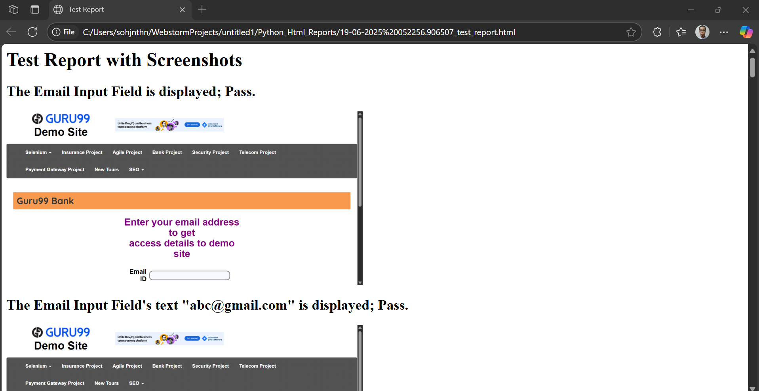

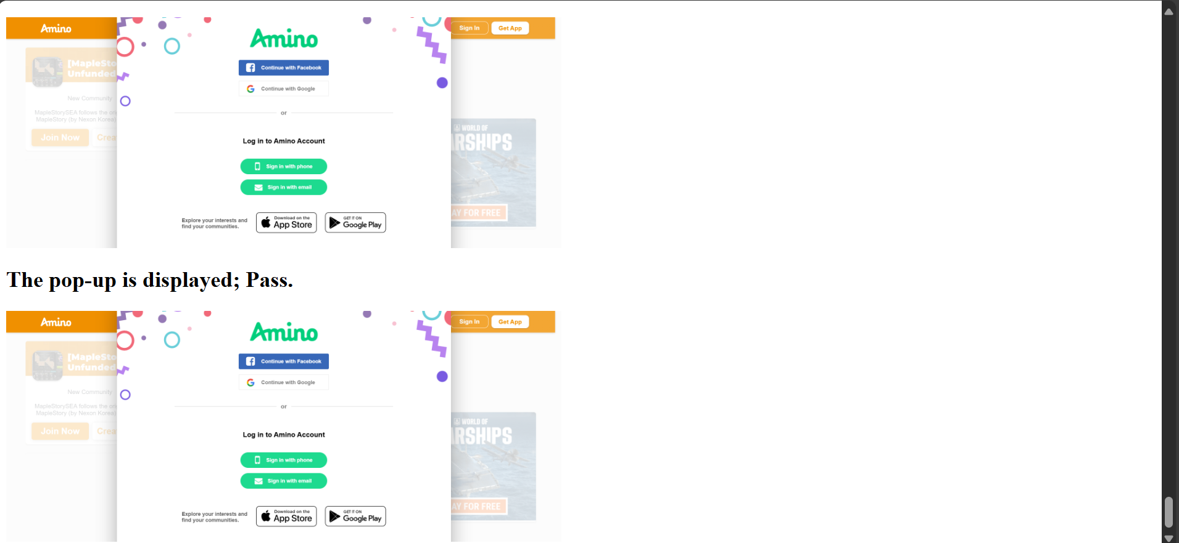

from appium import webdriver
from appium.options.android import UiAutomator2Options
from selenium.webdriver.common.by import By

from datetime import datetime

import os

def current_datetime_string_generator():
datetimee = datetime.now()
print("datetime is: " + datetimee.__str__())
datetimeeText = datetimee.strftime("%d-%m-%Y %H%M%S.%f")
datetimeeTextString = datetimeeText.__str__()
print("datetimeText is: " + datetimeeTextString)
return datetimeeTextString

def take_screenshot(driver, step_name):
datetimeeeText = datetime.now().strftime("%d-%m-%Y %H%M%S.%f")
datetimeeeTextString = datetimeeeText.__str__()
screenshot_path = os.path.join("C:\\Users\\sohjnthn\\WebstormProjects\\untitled1\\Python_Screenshot_Images\\" + datetimeeeTextString + "_screenshot.png")
driver.save_screenshot(screenshot_path)
return screenshot_path

def generate_html_report(screenshots):
report_path = "C:\\Users\\sohjnthn\\WebstormProjects\\untitled1\\Python_Html_Reports\\" + current_datetime_string_generator() + "_test_report.html"
with open(report_path, "w") as report:
report.write("<html><head><title>Test Report</title></head><body>")
report.write("<h1>Test Report with Screenshots</h1>")
for step, screenshot in screenshots.items():
report.write(f"<h2>{step}</h2>")
report.write(f'<img src="{screenshot}" alt="{step}" style="width:600px;"><br>')
report.write("</body></html>")
print(f"Report generated: {report_path}")

screenshots = {}

androidOptions = UiAutomator2Options()
androidOptions.platform_name = "Android"
androidOptions.automation_name = "UiAutomator2"
androidOptions.platform_version = "15"
androidOptions.app = "C:\\Users\\sohjnthn\\WebstormProjects\\untitled1\\app\\com.afwsamples.testdpc_9.0.12-9012_minAPI21(nodpi)_apkmirror.com.apk"

driver2 = webdriver.Remote("http://127.0.0.1:4723/wd/hub", options=androidOptions)

policyManagementText = driver2.find_element(By.XPATH, "//android.widget.TextView[@text=\"Policy management\"]")

for i in range(100):
print("Waiting for the display to complete the loading.")

datetimeTextString = current_datetime_string_generator()
driver2.save_screenshot("C:\\Users\\sohjnthn\\WebstormProjects\\untitled1\\Python_Screenshot_Images\\" + datetimeTextString + "_" + "screenshot.png")

if policyManagementText.is_displayed():
screenshots["\"Policy management\" is displayed; Pass."] = take_screenshot(driver2, "\"Policy management\" is displayed; Pass.")
else:
screenshots["\"Policy management\" is not displayed; Fail."] = take_screenshot(driver2, "\"Policy management\" is not displayed; Fail.")

androidOptions = UiAutomator2Options()
androidOptions.platform_name = "Android"
androidOptions.automation_name = "UiAutomator2"
androidOptions.platform_version = "15"
androidOptions.app = "C:\\Users\\sohjnthn\\WebstormProjects\\untitled1\\app\\ApiDemos-debug.apk"

driver3 = webdriver.Remote("http://127.0.0.1:4723/wd/hub", options=androidOptions)

datetimeTextString = current_datetime_string_generator()
driver3.save_screenshot("C:\\Users\\sohjnthn\\WebstormProjects\\untitled1\\Python_Screenshot_Images\\" + datetimeTextString + "_" + "screenshot.png")

appTab = driver3.find_element(By.XPATH, "//android.widget.TextView[@content-desc=\"App\"]")
if appTab.is_displayed():
screenshots["The App tab is displayed; Pass."] = take_screenshot(driver3, "The App tab is displayed; Pass.")
else:
screenshots["The App tab is not displayed; Fail."] = take_screenshot(driver3, "The App tab is not displayed; Fail.")
appTab.click()

datetimeTextString = current_datetime_string_generator()
driver3.save_screenshot("C:\\Users\\sohjnthn\\WebstormProjects\\untitled1\\Python_Screenshot_Images\\" + datetimeTextString + "_" + "screenshot.png")

searchTab = driver3.find_element(By.XPATH, "//android.widget.TextView[@content-desc=\"Search\"]")
if searchTab.is_displayed():
screenshots["The Search tab is displayed; Pass."] = take_screenshot(driver3, "The Search tab is displayed; Pass.")
else:
screenshots["The Search tab is not displayed; Fail."] = take_screenshot(driver3, "The Search tab is not displayed; Fail.")
searchTab.click()

datetimeTextString = current_datetime_string_generator()
driver3.save_screenshot("C:\\Users\\sohjnthn\\WebstormProjects\\untitled1\\Python_Screenshot_Images\\" + datetimeTextString + "_" + "screenshot.png")

invokeSearchTab = driver3.find_element(By.XPATH, "//android.widget.TextView[@content-desc=\"Invoke Search\"]")
if invokeSearchTab.is_displayed():
screenshots["The Invoke Search tab is displayed; Pass."] = take_screenshot(driver3, "The Invoke Search tab is displayed; Pass.")
else:
screenshots["The Invoke Search tab is not displayed; Fail."] = take_screenshot(driver3, "The Invoke Search tab is not displayed; Fail.")
invokeSearchTab.click()

datetimeTextString = current_datetime_string_generator()
driver3.save_screenshot("C:\\Users\\sohjnthn\\WebstormProjects\\untitled1\\Python_Screenshot_Images\\" + datetimeTextString + "_" + "screenshot.png")

prefillQueryTextField = driver3.find_element(By.XPATH, "//android.widget.EditText[@resource-id=\"io.appium.android.apis:id/txt_query_prefill\"]")
if prefillQueryTextField.is_displayed():
screenshots["The Prefill Query Text Field is displayed; Pass."] = take_screenshot(driver3, "The Prefill Query Text Field is displayed; Pass.")
else:
screenshots["The Prefill Query Text Field is not displayed; Fail."] = take_screenshot(driver3, "The Prefill Query Text Field is not displayed; Fail.")
prefillQueryTextField.send_keys("Test the text.")

for i in range(100):
print("Waiting for the display to complete the loading.")

datetimeTextString = current_datetime_string_generator()
driver3.save_screenshot("C:\\Users\\sohjnthn\\WebstormProjects\\untitled1\\Python_Screenshot_Images\\" + datetimeTextString + "_" + "screenshot.png")

if prefillQueryTextField.is_displayed():
screenshots["The Prefill Query Text Field's entered text \"Test the text.\" is displayed; Pass."] = take_screenshot(driver3, "The Prefill Query Text Field's entered text \"Test the text.\" is displayed; Pass.")
else:
screenshots["The Prefill Query Text Field's entered text \"Test the text.\" is not displayed; Fail."] = take_screenshot(driver3, "The Prefill Query Text Field's entered text \"Test the text.\" is not displayed; Fail.")

generate_html_report(screenshots)

